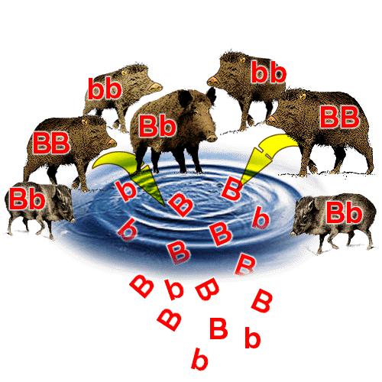**Natural Selection, Evolution and Evidence for evolution**

Q1. Give a definition for the following terms.

Sudden & permanent change in DNA base sequence.

Mutation:

A feature, body function or behaviour that enables the organism to survive in a new environment.

Adaptation:

The sum of all genes/alleles of a population.

Gene pool:

Group of similar individuals who are able to interbreed and produce fertile offsprings.

Species:

Individuals of the same species living in a particular place at a particular time.

Population:

The process of producing a new species from a common ancestor over a long period of time.

Evolution:

Q2. List four sources for genetic variation.

Mutation; independent assortment; crossing-over; random mating.

Q3. Outline two advantages of genetic variation.

Biodiversity and adaptation to a new environment so to avoid extinction.

Q4. Describe the three different types of adaptation, using an example for each.

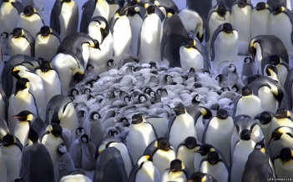**Structural/physical** adaptation: how the body is structured to allow the organism to survive in its environment. E.g. the spiky skin of an echidna allows it to protect itself from predation;

Double eyelashes on a camel’s eye to protect against sand

**Functional/physiological** adaptation: how the body functions at a cellular level to enable organisms to survive in their environment. E.g. the body of a desert hopping mouse producing little urine;

Venom in snake which is modified saliva to kill its prey; or

Fat stores in a camel’s hump to provide energy and water in a desert.

**Behavioural** adaptation: how the organism behaves in order to survive its environment. E.g. school of fish swimming together to avoid being eaten;

a pack of penguins huddling in the Antarctic to protect the young; or

dog marking its territory with urine under a tree to ward off intruders.

Q5. Four requirements for evolution are as follows. Describe the relevance/importance of each factor to evolution.

Variation: genetic variation permits natural selection to act on different individuals within a population.

Isolation: due to geographical, cultural or social factors. When two populations are isolated, there is no interbreeding/gene flow between them. They have separate gene pools.

Natural selection: a selective agent applies pressure on the gene pools of the two populations. A selective agent selects those with a favourable allele. They survive and reproduce and pass on their favourable allele to their offspring. This results in an increase of allele frequency in the gene pool. Those with an unfavourable allele die and their alleles are removed from the gene pool, resulting in a reduced allele frequency of the unfavourable allele.

Speciation: as the gene pools of the two populations become too different they form subspecies and over time as their genetic variation becomes too great, they develop reproductive isolation, whereby, they cannot interbreed to produce fertile offspring. Now they are classified as two distinct species.

Q6. What are homologous structures and how do they support the theory of evolution?

Homologous structures are structures that look similar between different species yet serve a different function. The greater the similarities between species structures, the closer they related genetically to a common ancestor.

Q7. What are vestigial organs and how do they support the theory of evolution?

These are reduced structures that serve no apparent function. They are inherited from earlier ancestors. E.g. nictitating membrane or appendix. The presence of these structures indicates that species are related and shared a common ancestor long time ago.

Q8. What are fossils and how they can support evolution?

Fossils at the preserved remains of traces of organisms from the past. By looking at the structure of the fossilised remains, archaeologists can study how species might have transitioned during their evolutionary period.

Q9. Identify four comparative studies that are used to study evolution.

Comparative anatomy(homologous structures & vestigial organs); comparative embryology; comparative protein sequence and comparative DNA.